Android jChat 1.4
User Guide

Last update: 28-September-2010

Authors: | Danilo Gotta  Stefano Semeria  Tiziana Trucco  Marco Ughetti



Contents
Introduction 3
Android jChat 1.4 setup 3
Setting the phone number 3
Customizing the GPS location provider 3
Launching JADE main container 5
Using Android jChat 1.4 6
Connecting to JADE 6
Knowing jChat 1.4 tabs 8
The Contact tab 8
The map tab 9
Picking contacts 10
Interacting with contacts 11
Sending an SMS to one or more contacts 11
Calling a contact 11
Starting a chat session 12
Using the status bar to browse chat sessions 12
Closing a chat session 13
Compiling and signing jChat 15
FAQ 16
LEGAL INFORMATION 17
Terms and Conditions of use 17
Limited use 17
Disclaimer 17
Information from you 17
Law and Jurisdiction 17

Introduction
jChat application is an agent based IM-style application for Android , based on JADE (http://jade.tilab.com).
It allows the user to communicate with any other contact having the same software running and connected to the same JADE platform. Users can send text IM in a chat like way, call a contact by phone or even send an SMS to a contact.
Moreover, the position of each contact can be seen on the map at any time and it is continuously updated.
jChat 1.4 has been tested on Android 2.2.

Android jChat 1.4 setup
In order to be able to start and use the jChat 1.4 application, a few configuration steps are required.

Setting the phone number
jChat 1.4 application uses the phone number as the agent ID of each contact. When running of the real phone the application tries to retrieve the real phone number using the Android API. If for some reason the phone number cannot be retrieved it must be set using the Jade Setting dialog (see Connecting to JADE)
Due to some API changes from Android SDK 0.9 to 1.0, phone number customization is no more possible on the emulator. In this case, jChat 1.4 uses the emulator default telephone number and appends a random integer to ensure the uniqueness when using multiple instances of the phone emulator.

Customizing the GPS location provider
jChat 1.4 allows to a user to see both his position and his contact’s on a map. When running on the emulator jChat 1.4 uses a mocked GPS.
To send custom tracks to jChat 1.4 you can use the DDMS tool that allows to send mock data location to the emulator. Instructions on using the DDMS tool can be found at http://developer.android.com/guide/developing/tools/ddms.html. An example of .kml file is provided with the source code in the cfg/locations folder.
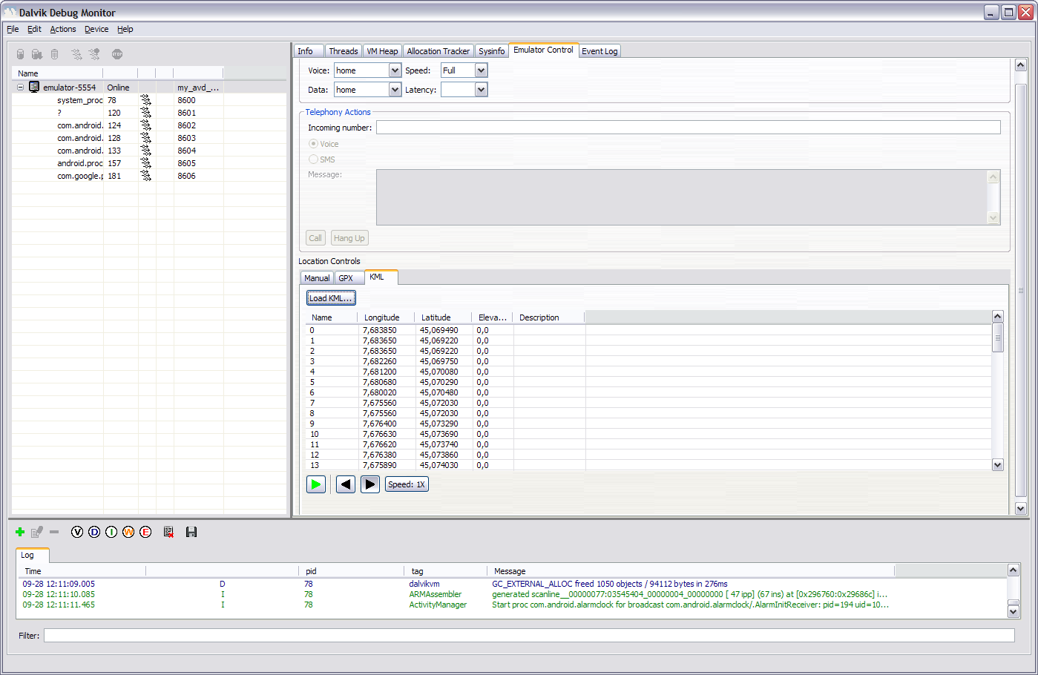
Figure 1

Launching JADE main container
To be able to run jChat 1.4, a JADE Main container must be launched.
A JADE container MUST be running when jChat 1.4 connects to it, otherwise the application will hang.
These are the steps that should be executed:
- Download the last JADE release from http://jade.tilab.com.
- Launch a JADE main container, together with JADE RMA GUI issuing the following command
java -cp <PATH_TO_JADE>\jade.jar -Djade_domain_df_autocleanup=true jade.Boot -gui
Please note that the option -Djade_domain_df_autocleanup=true is necessary to correctly cleanup the DF agent.

Using Android jChat 1.4

Connecting to JADE
The first step for using jChat 1.4 is the connection to a JADE main container running on a host machine (local or remote). Please note that (differently from jChat 1.0) before connecting to Jade the screen will appear black. The GUI SHALL become visible only after a successful connection to Jade.
The default host machine and the port for the main container are specified on strings.xml file during compilation (this is the default value).
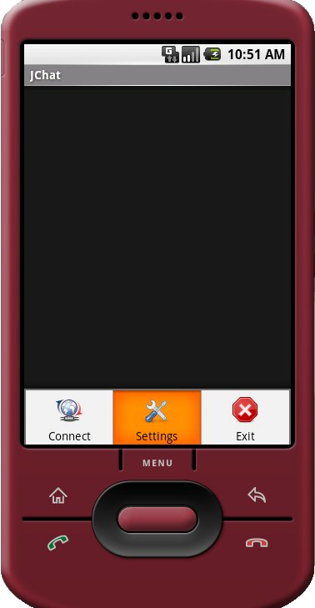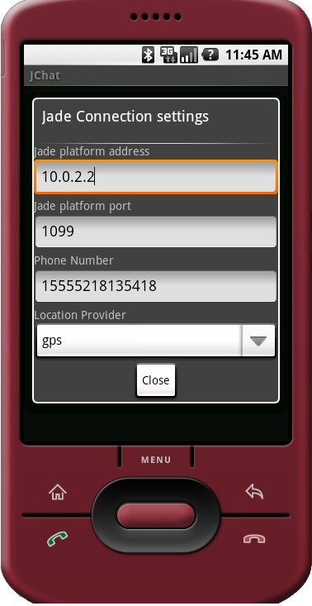
Figure 2
To change these settings perform the following steps (see Figure 1):
- Press the MENU key on the emulator
- Choose Settings
- Insert the needed settings (host and port and phone number if empty). You are also able to select the desired location provider (on a real phone you can use the GPS or the network if GPS is not available, on the emulator just select gps for the mocked provider). Remember that the localhost address on Android emulator is 10.0.2.2. jChat 1.4 shall now remember the settings you choose in the Jade Connection settings menu storing them as a preference, so you don’t have to enter them any time you launch the application
- Press Close button
- Press the MENU key on the emulator
- Choose Connect to Jade!
If running on a real phone remember that your host must be visible through the network used (3G or wifi).
If the connection to Jade platform is successful you should be able to see the new agent running on Android emulator into Jade Remote Agent Management GUI.
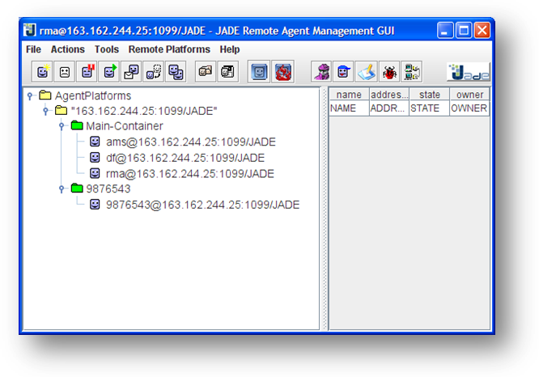
Figure 3
The name of the new agent should be the same as the phone number of the phone.

Knowing jChat 1.4 tabs
The main screen is divided into two different tabs, providing contacts information in different visual ways.

The Contact tab
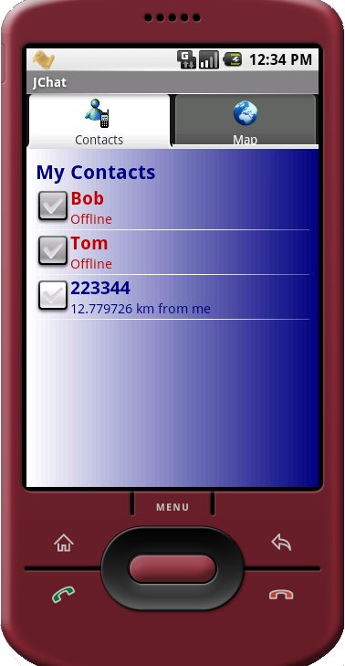
Figure 4

The contact tab contains a list of all currently available contacts.
Any contact can be online (connected to our JADE Leap platform) or offline.
Online contacts are shown in blue, while offline contacts are shown in red.
For each online contact the distance in km between the phone owner and the contact is shown.

The map tab
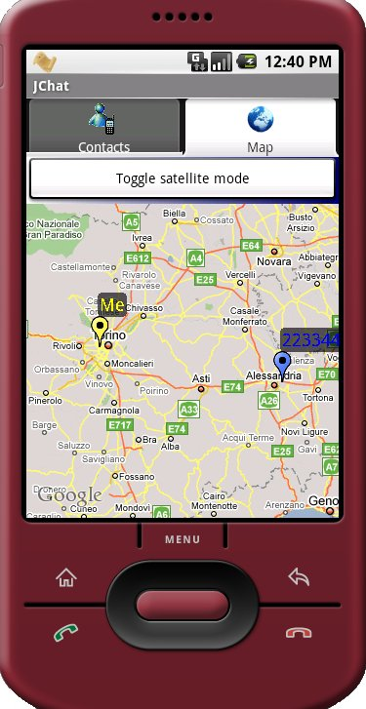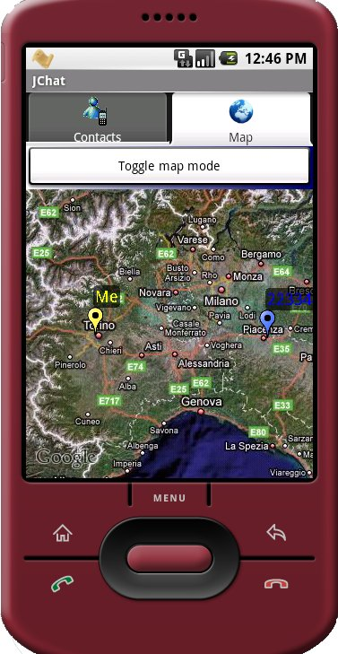
Figure 5

The map tab shows the position of each online contact on a map and continuously updates their position.
Each contact is visible as a pin of different colors: the phone owner can see his own position as a yellow pin, while others contacts are shown as blue pins.
Maps can be seen both in traditional map mode and in satellite mode: the user is able to switch between the two modes using the switch button placed right above the map.

Picking contacts
To be able to communicate with others, users must first select contacts (“picking”).
You can pick one or more contacts in both contact tab and map tab.
In contact tab, you have to click on the checkbox beside each contact. In map tab you simply click on the pin representation of the contact.
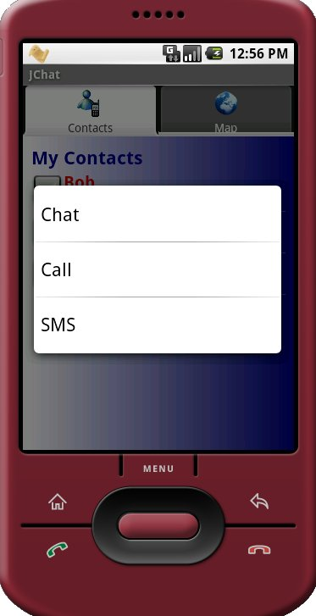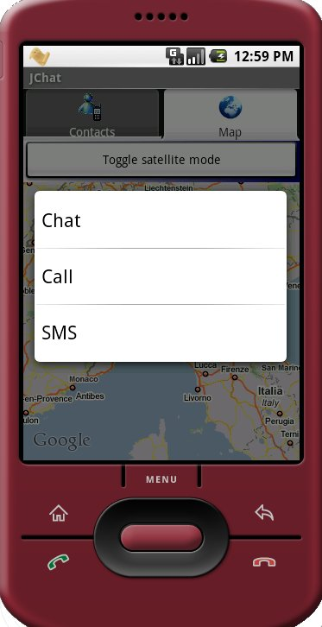
Figure 6
Please note that contact selection is local to the map (you cannot begin selecting contact in a tab, then switch to the other tab and continue selection).
After contacts selection, you can decide how to interact by pressing for some seconds the emulator selection button and choosing the desired option from the context menu that will popup.

Interacting with contacts
Users can communicate with contacts in three ways: SMS, phone calls or chat sessions.

Sending an SMS to one or more contacts
After choosing to send an SMS message, user will be redirected to the SMS sending screen. Obviously a message can be sent to more than one contact at the same time.
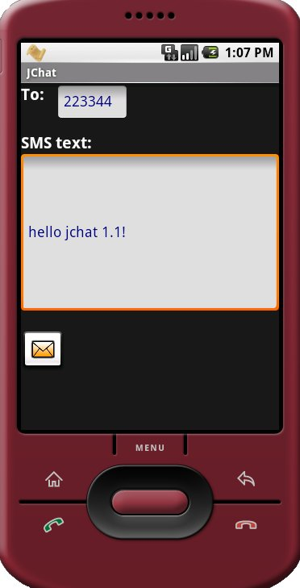
Figure 7
Here he will be able to enter the message text and to send it.
Message shall be split into chunks if too long and sent to the desired contact/s.
Please note that at the moment the emulator does not support SMS sending emulation, so nothing shall be received. The SMS sending process is mocked and it always succeeds. SMS sending process is real on the G1 hardware.

Calling a contact
If you choose to call a contact, the calling screen shall appear and the call shall start.
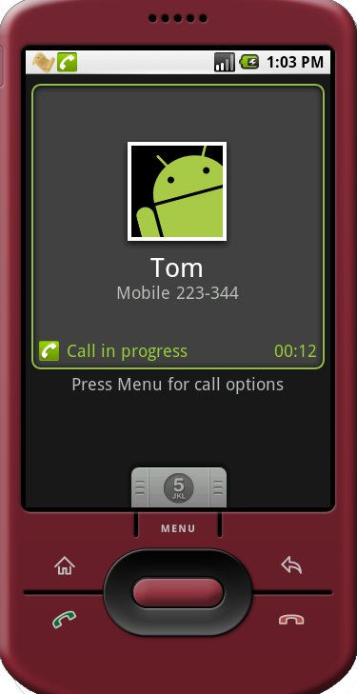
Figure 8
Obviously, the phone call is totally mocked on the emulator while it is a real phone call on the G1.
If you try to call more than one contact at the same time (by selecting many contacts and choosing Call from context menu) a message shall appear warning that only one contact can be called at the same time.

Starting a chat session
We define chat session as a group of two or more contacts talking together.
A chat session can be started by the phone owner (by selecting contacts and choosing Chat from the context menu) or by another contact that wants to talk with the phone owner himself.
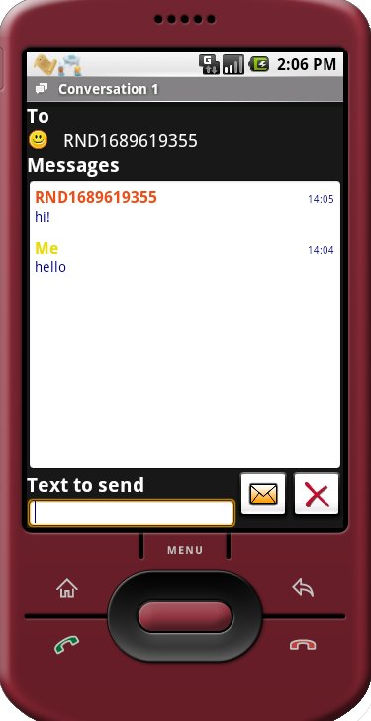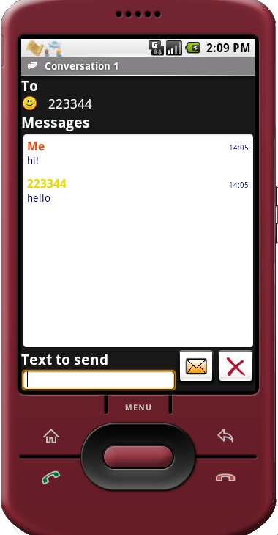
Figure 9

If the user chooses to start a chat session, the chat screen shall appear. In this screen you will be able to see the list of the other session participants, to enter a text message, to send it and to see a list of all the conversation messages with timings.

Using the status bar to browse chat sessions
Whenever a chat message is received from another contact, a toast notification is shown and a persistent notification is added to the status bar. Also starting a new session adds a new persistent notification.
In this way the user can switch between many different ongoing conversations by using the status bar.
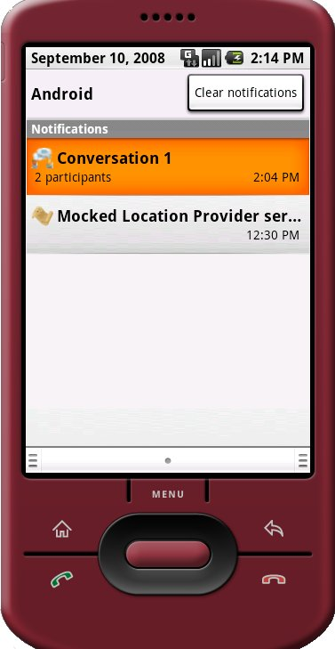
Figure 10
These are the required steps:
- Drop down the Android status bar. The list of active sessions' notifications shall appear. Please note that you’ll have a notification for each ongoing chat session, it does not matter who started the conversation.
- Choose the session you’re interested in and click on its notification.
- A new chat session shall start (or the session switches to the new one if a chat session was already opened)
Each time a conversation notification is selected the chat session is redrawn.

Closing a chat session
To close a chat session, simply press the cross button next to the send button in the chat screen.
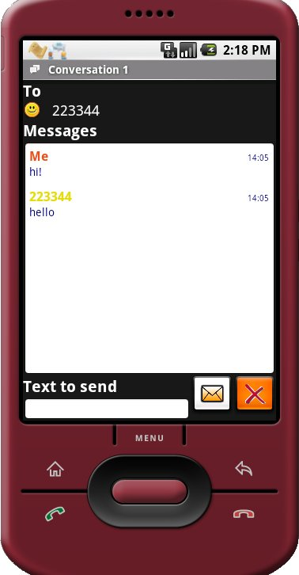
Figure 11
Please note that the emulator’s BACK key will simply close the chat screen but the session will remain open (all conversation messages will be kept) and the user will be able to restore it by choosing the notification on the status bar.
After choosing the cross button the session will be removed and all previously sent messages will be lost.
G1 specific notes
All the selection operations must be performed by touching the screen device. The long press event for showing the Call/Chat/SMS menu must be performed by pressing a selected name for a long time in the contacts tab and by pressing the trackball in the map tab.
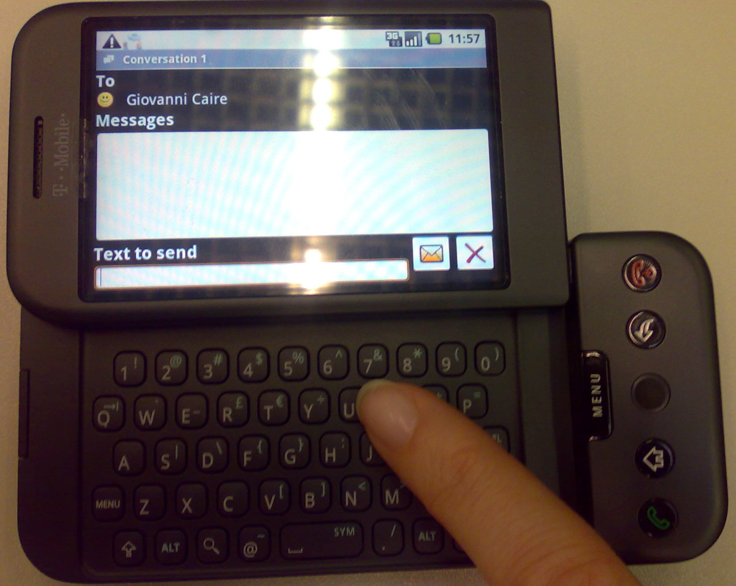
Figure 12
Entering text requires a rotation of the screen for using the QWERTY keyboard (G1 has no virtual keyboard).
When screen is rotated, the height available for lists of elements (message list in the chat or contacts list in the Contact tab) is reduced.
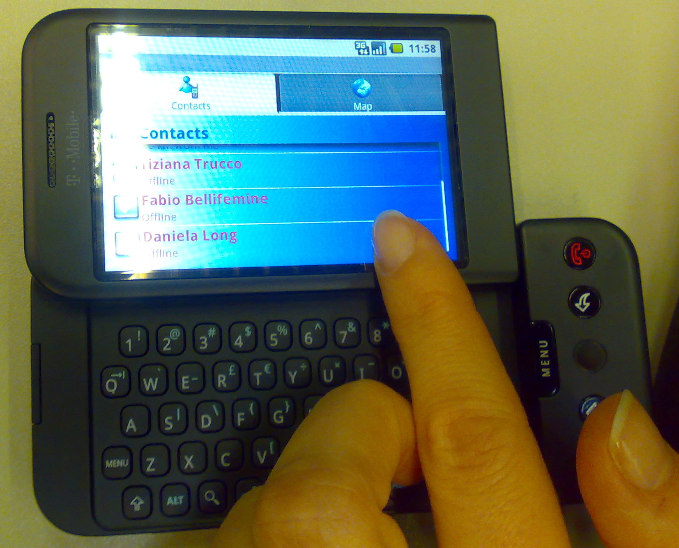
Figure 13
If you want to see the full list contents, you have to scroll by moving your finger up or down on the screen.

Compiling and signing jChat
In order to compile jChat you have to create a new Android Project using Eclipse, assuming that you have installed the ADT plugin in your Eclipse environment. Using the new Android Project wizard, select the “Create from existing source” and set the Location field to the directory where you downloaded jChat (i.e. C:\myprojects\jChat). For further details on how to create an Android project can be found on the Android site (http://code.google.com/android/index.html).
After the project has been created, you must set the following dependencies:
- Project→Properties→Java Build Path: select the Libraries tab then Add External JARs and move to the jChat directory select into the libs directory the JadeLeapAndroid.jar library.
jChat uses the MapView in order to access the Google Maps data, so we registered the MD5 fingerprint of our debug certificate, used to sign the jChat application, to obtain a Maps API Key. Then the Maps API key reference has been added in the jChat/res/layout/homepage.xml in the MapView declaration. When you run or debug your application, ADT signs the .apk with the debug certificate and installs it on the emulator/phone. So if you want to enable your jChat project to access the Google Maps data you have to:
- Register your debug certificate to the Google Maps service following the instructions provided at the Android site (http://code.google.com/android/index.html) and then set your Maps API Key into the MapView declaration in <yourPath>/jChat/res/layout/homepage.xml.

FAQ

Q: Can I have different instances of the emulator running jChat ?
A: If you want to run different jChat instances you still should use the command:
emulator –data <PATH_TO_IMAGE>\userdata2.img
Q: I launch the application but when I choose Connect to Jade from the menu, the application hangs. Why?
A: Probably you forgot to launch a JADE Leap main container. A main container is needed for the application to start.
Q: Sometimes I got a message saying “Error sending broadcast null” when closing the application. Why?
A: This seems to be a known bug of Android emulator when shutting down the location update.

LEGAL INFORMATION

Terms and Conditions of use
jChat is an open source project supported by Telecom Italia S.p.A. (“Telecom Italia”).

Limited use
The Telecom Italia logo displayed on this website is the property of Telecom Italia: it cannot be used without the prior written consent of Telecom Italia S.p.A.. The Telecom Italia name or any trademark including the trademark TELECOM ITALIA cannot be incorporated into an Internet Address without the prior written consent of Telecom Italia S.p.A..

Disclaimer
The information on this website is provided in good faith and Telecom Italia believes it to be accurate. Telecom Italia will not under any circumstances be liable for any loss of income, profit, business, contracts or goodwill or any indirect or financial loss suffered by a party, whether arising in contract, negligence or otherwise. The information on this website may include typographical errors. Information may be changed or updated without notice. Telecom Italia may also make improvements and/or changes in the sections of this website without notice.

Information from you
Any materials sent to Telecom Italia, for example by e-mail or via World Wide Web pages, shall be deemed not confidential. Telecom Italia shall have no obligation of any kind with respect to such materials and Telecom Italia shall be free to reproduce, use, disclose, display, transform, create derivative works and distribute the materials to others without limitation. Further, Telecom Italia shall be free to use any ideas, concepts, know-how or techniques contained in such materials for any purpose whatsoever, including but not limited to, developing, manufacturing and marketing products incorporating such materials. You warrant that such materials are fit to publication and you agree to indemnify Telecom Italia if any third party takes action against Telecom Italia in relation to such materials.

Law and Jurisdiction
For any dispute arising from these terms and conditions and activities covered thereto the Court of Milan, Italy, shall have not exclusive jurisdiction and the Italian laws shall apply Telecom Italia nonetheless reserves the right to take legal proceedings in country other than Italy, to protect its interests or to enforce its rights whenever it deems it appropriate to do so.

